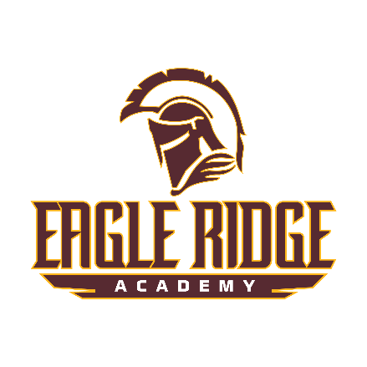

Eagle Ridge Academy is seeking a dedicated **High School English eacher** for the remainder of the 2024-2025 school year.

Text **ERAEL24A** to (720) 964-1157 to start the application!

**About Eagle Ridge Academy**

[Eagle Ridge Academy](https://www.eagleridgeacademy.net/) is a college preparatory high school located in Brighton, CO. With our strong focus on student achievement, students are ready to succeed at the college level by the time they graduate from ERA! ERA has one of the highest graduation rates in the Denver Metro area. Our students have the highest SAT and PSAT scores in School District 27J. On top of this, ERA graduates are accepted to 4-year universities at an average of 85%, and 2 or 4-year colleges at a rate of 100%.

**What can I expect as an ERA team member?**

Staff and faculty of ERA help to guide and support our students through their academic career. You can expect to challenge your students, encourage them to take a chance, expand their horizons, and ensure they reach their full potential while growing into a phenomenal human being. You will be a vital part of helping us to achieve our organization's “Why” of fostering an inclusive environment so that students become high-achieving lifelong learners!

**What support will I get as a teacher?**

ERA has a dynamic group of staff that are collaborative and supportive. You will receive specialized coaching from our experienced instructional coach as well as mentorship, and job-embedded, specific professional learning to support your individual success. ERA utilizes Teach Like a Champion teaching framework and professional development programs which include techniques and strategies to increase student engagement, learning, and achievement. We believe these strategies help to foster high-quality teaching and learning, as well as enhance the overall academic performance of students.

**Salary:**

The salary schedule for this position can be found on our website or here - [Salary Information](https://drive.google.com/file/d/18_0KvXB8ONAhRPr59Mxgb-XedtkBMlaU/view). The salary for a teacher with a bachelor’s degree begins at $52,000 - $73,474.64 (**no experience cap**). A teacher with a master’s degree begins at $56,000-$79,126.53 (**no experience cap**).

**What benefits does ERA offer?**

We offer a robust, comprehensive benefits package that includes:

* Medical, basic life, short/long term disability, and Ad&D plans (100% employer paid)
* Health savings plan with an annual employer contribution of up to $750.00
* Dental and vision plans (100% employer-paid)
* Participation in the Colorado Public Employees Retirement Association (PERA) - click [here](https://www.copera.org/) to learn more!
* Various retirement options including 401k, 403b, 457, and Roth IRAs
* Flexible Spending Accounts (FSA) to include Healthcare and Dependent Care
* AFLAC voluntary benefits include critical illness, hospital plans, as well as others
* Professional liability coverage through the Professional Association of Colorado Educations (PACE) - click [here](https://www.coloradoteachers.org/) to learn more (100% employee paid)

Additional information about our current benefits pages can be found [here](https://drive.google.com/file/d/1Yc6hetldUO46HkuSJDM9kUNzaQ5oDyqv/view?usp=sharing).

**Required Qualifications:**

* A valid Colorado Department of Education Teaching License or enrolled in an alternative licensure teaching program by the start of employment.
* Colorado Department of Education “In Field” by CDE endorsement or qualifications to teach the posted subject area.
* The ability to handle many complex tasks simultaneously.
* The ability and interest to be part of a high-functioning team. (Having respect and trusted colleagues, preferably as teammates, makes the demands of teaching sustainable.)
* The ability and interest to learn continuously and to adapt to changing circumstances (student characteristics, curriculum, and so on).
* A belief in empowering all children as owners of their own learning.

**Application Procedure:**

Eagle Ridge Academy is actively seeking applications from the most capable and professional candidates. Please complete our online application to be considered for this position. Apply by clicking here: [Careers At Eagle Ridge Academy](https://era.hrmdirect.com/employment/job-openings.php?search=true&&cust_sort1=229747).

**Non-Discrimination Notice:**

In compliance with Titles VI and VII of the Civil Rights Act of 1964, Title IX of the Education Amendments of 1972, Section 504 of the Rehabilitation Act of 1973, the Age Discrimination in Employment Act of 1967, the Americans with Disabilities Act, the Genetic Information Nondiscrimination Act of 2008, the CROWN Act, and Colorado law, Eagle Ridge Academy does not unlawfully discriminate on the basis of race, color, sex, retaliation, national origin, ancestry, creed, age, marital status, sexual orientation, gender identity, gender expression, genetic information, pregnancy status, disability, need for special education services, or hair texture and protective hairstyles in admissions, access to, treatment, or employment in its programs and activities. The school is committed to ensuring non-discrimination in all its operations.

**Posting Timeline: October 23, 2024**, through **November 23, 2024,** or until filled.